**Exercise 3: Assertions in Junit**

**Overview**

This project demonstrates the use of various JUnit 5 assertions to validate test results in a Java application. The AssertionsTest class contains individual test methods, each showcasing a different JUnit assertion (assertEquals, assertTrue, assertFalse, assertNull, assertNotNull, assertSame, assertNotSame, assertArrayEquals, and assertThrows). The project is configured to run in Eclipse IDE with Maven .

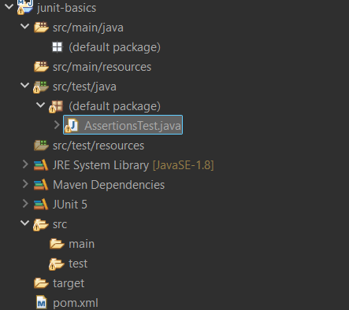

**AssertionsTest.java :**

import org.junit.jupiter.api.Test;

import static org.junit.jupiter.api.Assertions.*;

public class AssertionsTest {

@Test

public void testAssertEquals() {

assertEquals(5, 2 + 3, "2 + 3 should equal 5");

}

@Test

public void testAssertTrue() {

assertTrue(5 > 3, "5 should be greater than 3");

}

@Test

public void testAssertFalse() {

assertFalse(5 < 3, "5 should not be less than 3");

}

@Test

public void testAssertNull() {

assertNull(null, "Object should be null");

}

@Test

public void testAssertNotNull() {

assertNotNull(new Object(), "Object should not be null");

}

@Test

public void testAssertSame() {

String str = "Hello";

assertSame(str, str, "Should be the same object");

}

@Test

public void testAssertNotSame() {

assertNotSame(new String("Hello"), new String("Hello"), "Should be different objects");

}

@Test

public void testAssertArrayEquals() {

int[] expected = {1, 2, 3};

int[] actual = {1, 2, 3};

assertArrayEquals(expected, actual, "Arrays should be equal");

}

@Test

public void testAssertThrows() {

assertThrows(ArithmeticException.class, () -> {

int result = 1 / 0;

}, "Division by zero should throw ArithmeticException");

}

}

OUTPUT:

